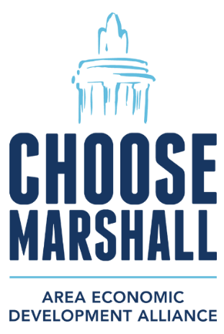
FOR IMMEDIATE RELEASE: Friday, Feb. 28, 2025
CONTACT: Amy Bailey, Byrum & Fisk Advocacy Communications, abailey@byrumfisk.com
MAEDA transfers land to BlueOval Battery Michigan LLC, now Marshall’s largest industrial property owner
BlueOval Battery Michigan LLC takes ownership of the 500 acres where battery manufacturing facility is taking shape
MARSHALL, Mich. — The Marshall Area Economic Development Alliance (MAEDA) has transferred 500 acres of land that is home to the future BlueOval Battery Park Michigan to BlueOval Battery Michigan LLC, a wholly owned subsidiary of Ford Motor Company, making BlueOval Battery Michigan LLC the largest industrial property owner in Marshall.
The city of Marshall is expected to receive more than $2 million annually in new revenue when BlueOval Battery Park Michigan is up and running. Marshall Township and other nearby communities also will receive significant new revenue gains because of the facility that will create approximately 1,700 local jobs and eventually produce batteries for electric vehicles.
“Ford has been an incredible neighbor and community partner, supporting dozens of programs and services across the region,” said James Durian, CEO of MAEDA. “We’re excited to see progress on this project that has already created hundreds of local construction jobs in and around the Marshall Area Jobs, Opportunity and Recreation (MAJOR) Campus, adding to foot traffic for our local restaurants, area shops and small businesses.”
More than 800 workers are constructing the battery facility as well as the infrastructure related to the MAJOR Campus. These contractors include Battle Creek-based Hoffman Brothers, Lansing-based Granger Construction and more than 20 others to complete the water and wastewater infrastructure improvements. That’s in addition to the Walbridge employees working on the construction of the BlueOval Battery Park Michigan facility.
“With this project in Marshall, our small business is putting people to work building long-lasting infrastructure that will benefit our families, friends and neighbors for years to come,” said Dan Eriksson, CEO of Hoffman Brothers. “The MAJOR Campus will attract additional investments for our region, which means higher property values and funding for police, fire, schools and roads.”
Through its wholly owned subsidiary, Ford in December completed steel construction on the primary facility, which is expected to begin production in 2026. The automaker hosted a ceremony to mark the milestone by putting into place the final beam signed by team members along with a U.S. flag and a tree for good luck. Construction continues on other BlueOval Battery Park buildings at the site as well as inside the plant.
“This is another positive signal that we are on track to begin production in 2026, and we are continuing to hire so that we can build the best possible team to lead this advanced manufacturing facility,” said Scott Davis, CEO of BlueOval Battery Michigan LLC and a Marshall resident.
To date, Ford has invested more than $450,000 to fund a number of Calhoun County organizations and services, including Marshall Public Schools, Marshall Bucks matching program to support local business, the Bohm Theater, the Binder Park Zoo, and the City of Marshall for tree planting and repairs to the Brooks Memorial Fountain.
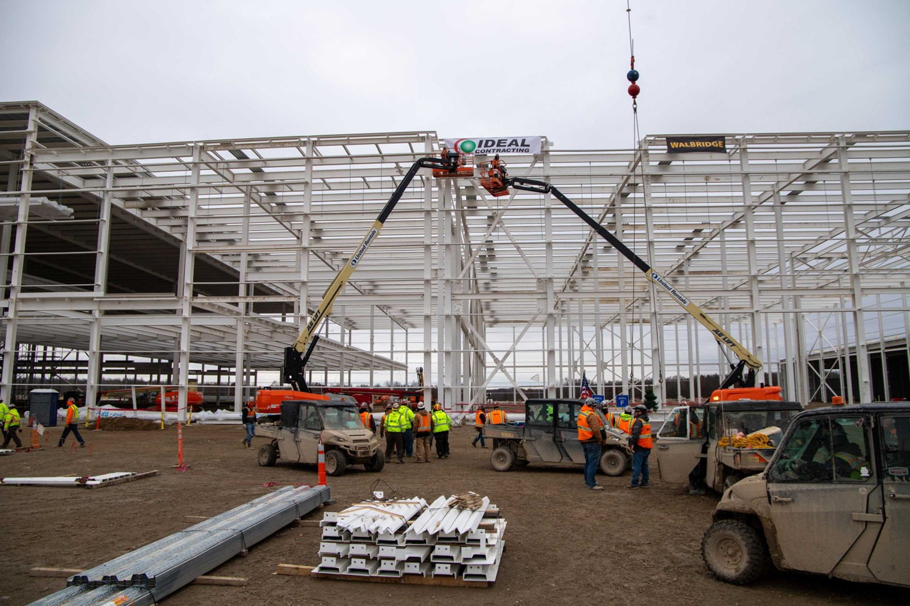Ford hosted a "topping out” ceremony in December to mark the completion of steel construction for the 1.8 million-square-foot facility that will be BlueOval Battery Park Michigan in Marshall.
###

