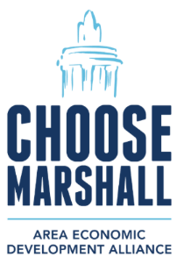

**FOR IMMEDIATE RELEASE**: Thursday, Sept. 25, 2025  
CONTACT: Amy Bailey, **Byrum & Fisk Advocacy Communications**, [abailey@byrumfisk.com](mailto:abailey@byrumfisk.com)

**Ford hits hiring milestone for project in Marshall, already paying taxes on BlueOval Battery Park Michigan**

*More than 100 employees hired by Ford for BlueOval Battery Park Michigan, nearby road construction using several Michigan-based firms*

**MARSHALL, Mich.** — **Ford’s** project in Marshall is continuing to hit incredible milestones, generating widespread benefits for the state and local economies and creating jobs for thousands of skilled trades workers with work on the site as well as nearby road construction.

Ford’s **BlueOval Battery Park Michigan** has hired more than 100 employees for the facility, which is on track to begin production next year when 1,700 workers are expected to be employed there. Ford’s wholly owned subsidiary **BlueOval Battery Michigan LLC** took ownership of the 500-acre site in Marshall late last year, making it the city’s largest industrial property owner, and it is already paying property taxes.

When construction of BlueOval Battery Park Michigan is finished, the city of Marshall will see more than $2 million annually in new tax revenue. Of that new funding, Marshall Township will receive more than $383,000 annually compared to the approximately $21,000 in annual revenue the Township received from the property prior to the construction of the Ford facility.

“BlueOval Battery Park Michigan will benefit the Marshall area for years to come, and it is already making a positive impact on our communities,” said **Derek Perry,** City Manager of Marshall. “It’s exciting to see the broad benefits of the project today as well as the increased tax revenue that will support police and fire, roads, parks, recreation, transit, local libraries and our schools.”

Late last year, Ford completed steel construction on the 1.8 million-square-foot facility that will be BlueOval Battery Park Michigan. Construction to revamp and improve nearby roads is well underway and the **Michigan Department of Transporation** (MDOT) is working with several Michigan-owned firms to complete that work, expanding the economic benefits of the project well beyond southwest Michigan. Firms working with MDOT on roadwork in and around Marshall are:

* [C.A. Hull](https://www.cahull.com/) of Walled Lake on bridge work,
* [Hoffman Bros. Excavating Contractors](https://www.hoffmanbrosinc.com/) of Battle Creek on excavating,
* [Ajax Paving Industries, Inc.](https://www.ajaxpaving.com/) of Troy on concrete pavement,
* [Anlaan Corporation](https://www.anlaan.com/) of Grand Haven on culverts and bridges, and
* [Michigan Paving & Materials Company](https://www.michiganpaving.com/) of Kalamazoo on flexible pavement.

“With 2,200 skilled trades workers currently on site making an average annual salary of $73,000, that’s $160 million of annual wealth generated for Michigan residents – from just this project,” said **James Durian**, CEO of the **Marshall Area Economic Development Alliance** (MAEDA). “It is incredibly rewarding to see this project help our economy here in Marshall and also ripple far out to other regions across the state.”

MAEDA recently celebrated the start of improvements to the local wastewater treatment plant that will handle increased sanitary flow from Ford’s BlueOval Battery Park Michigan and future businesses at the **Marshall Area Jobs, Opportunity and Recreation (MAJOR) Campus**.

“These upgrades make our wastewater treatment plant more resilient, improve the longevity of our infrastructure and ultimately lower costs for our water and sewer customers,” said **Marguerite Davenport**, director of Public Services for the city of Marshall.

This work follows other infrastructure projects on the [MAJOR Campus](https://choosemarshall.com/economic-development/major-campus/construction/) and at the existing water treatment plant that provide a reliable and consistent water supply and distribution system for businesses and residents across several area communities. Those include:

* [4.5-million-gallon water storage](https://youtu.be/7K7SjniIytA?si=BOl-XlPX9Kc7Moen) tank,
* new high-service pump station,
* new backup generator to continue treating water during a power outage,
* replacement of water treatment filters, and
* upgraded electrical and remote operational controls.

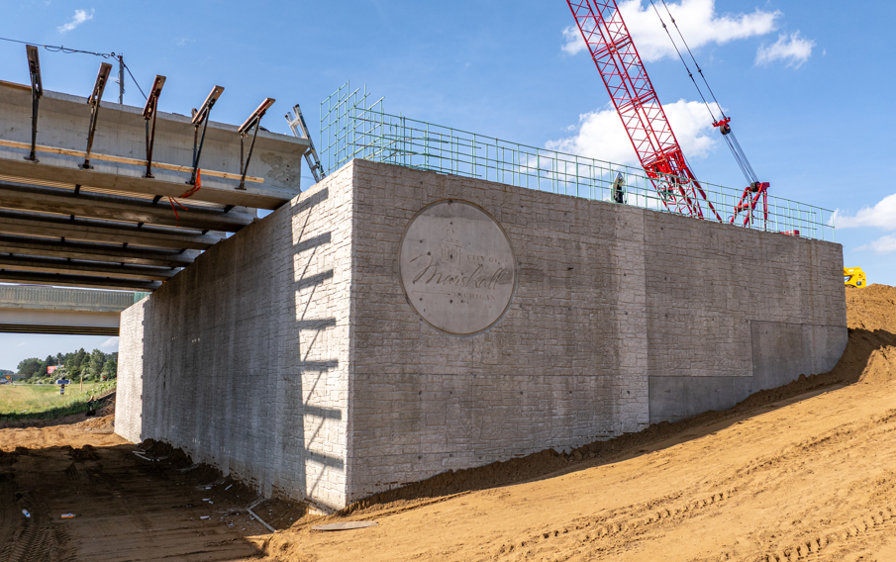

*MDOT is working with several Michigan-based firms to complete roadwork projects in and around Ford’s BlueOval Battery Park Michigan.*

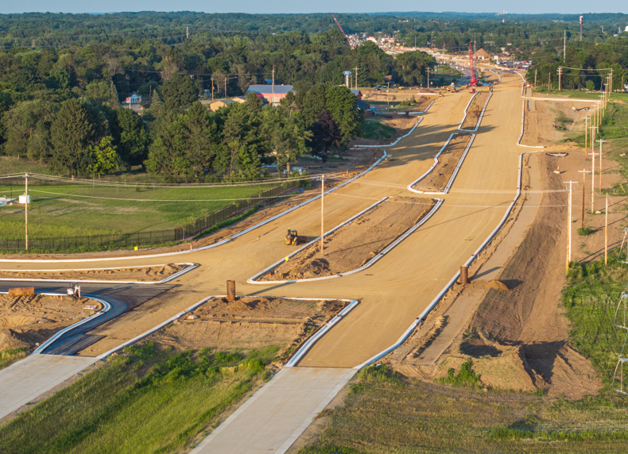

*Construction to revamp and improve nearby roadways is well underway in and around Marshall to accommodate increased traffic when Ford’s BlueOval Battery Park Michigan begins production in 2026.*

###