

FOR IMMEDIATE RELEASE: Wednesday, Dec. 17, 2025
CONTACT: Amy Bailey, Byrum & Fisk Advocacy Communications, abailey@byrumfisk.com
MAEDA, Emmett Township celebrate infrastructure project honored by industry leaders for collaboration
Public works group honors Emmett Township’s water transmission line that supplies Ford facility, future MAJOR Campus businesses
MARSHALL, Mich. — The Marshall Area Economic Development Alliance (MAEDA) and local officials are applauding engineers and skilled trades workers who were honored by industry leaders for their recently completed water transmission project in Emmett Township.
The Verona Road Watermain Extension project was among the 2025 Public Works Project of the Year regional award recipients named by the Southwest Michigan Branch of the American Public Works Association (APWA).
The project was part of a regional water solution to support Ford’s BlueOval Battery Park Michigan at the Marshall Area Jobs, Opportunity and Recreation (MAJOR) Campus. It was among APWA’s regional award-winning projects among small cities and rural communities, which include those cities or counties with a population of 50,000 or less. It was awarded to Emmett Charter Township and MAEDA, along with consultants Fleis & VandenBrink and contractors Granger Construction Co. and Hoffman Bros., Inc.
“This combined effort with Choose Marshall allowed our township to meet standards laid out by the state’s environmental agency and saved us roughly $13 million,” said Tracy Myers, supervisor of Emmett Charter Township. “We appreciate the great work and collaboration of the local organizations and municipalities involved in this project, especially our engineers at Fleis & VandenBrink, who designed the loop to make it happen.”
The Emmett Township Loop Water Transmission Main supplies water from the City of Battle Creek through Emmett Charter Township to bring up to 5 million gallons of water per day to Ford’s BlueOval Battery Park Michigan and future businesses at the MAJOR Campus. Along with water from the city of Marshall, water from the Emmett loop will be stored at the ground storage tank on the MAJOR Campus.
“These improvements to our water treatment and delivery system benefit thousands of people who live and work in Marshall Township, the city of Marshall and Emmett Township,” said James Durian, CEO of MAEDA. “These investments will mean higher property values, lower insurance rates and quicker access to water during an emergency.”
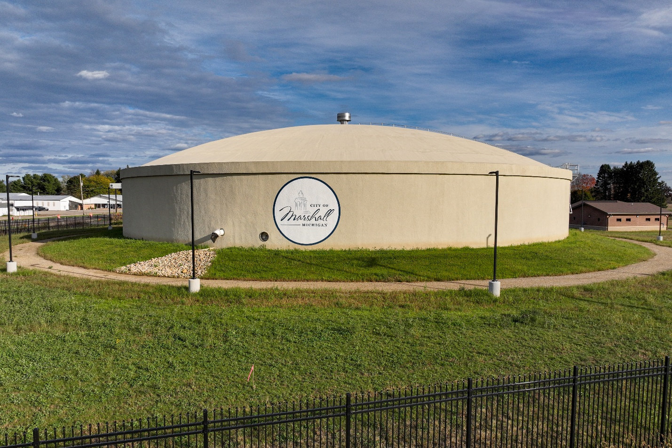The 4.5-million-gallon water storage tank on the MAJOR Campus is part of new water and sewer infrastructure that includes 14 miles of water transmission main, new water filter tanks, well houses and an automated filter system.
###

