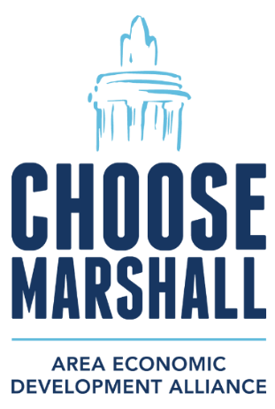
FOR IMMEDIATE RELEASE: Wednesday, June 25, 2025
CONTACT: Amy Bailey, Byrum & Fisk Advocacy Communications, abailey@byrumfisk.com
Marshall leaders, local business owners showcase local support for Ford’s BlueOval Battery Park Michigan
Community leaders highlight economic benefits of local Ford project, point to a bright future ahead
MARSHALL, Mich. — “The future of Marshall looks better today than it has in 40 years.”
That’s how Scott Wolfersberger, mayor of the City of Marshall, summed up the sentiment in the community as the Ford facility, called BlueOval Battery Park Michigan, takes shape. The facility will create 1,700 new jobs next year when it begins producing batteries for electric vehicles.
“I believe that Marshall is better positioned to be that vibrant city that I grew up in with Ford BlueOval as a part of the community,” Wolfersberger said. “Ford is truly a great American company, and we should all be proud that they selected Marshall as the place to invest for its long-term future.”
Wolfersberger was among a handful of local leaders and small-business owners who participated in a virtual press conference on Wednesday to showcase support for BlueOval Battery Park Michigan, detail its immediate and ongoing benefits to the local economy in terms of new jobs, investment and a tangible boost to local small businesses
Leaders also hailed this week’s public tour of the 1.8 million-square-foot facility. A recording of the press conference is available on YouTube.
More than 1,500 skilled trades workers report to work every day on and around Ford’s project and the Marshall Area Jobs, Opportunity and Recreation (MAJOR) Campus. These workers are contributing to the local economy right now by shopping at independently owned small businesses, dining at local restaurants and staying at nearby hotels.
“As the owner of three small businesses in Marshall, the immediate and long-term positive economic impact of Ford’s investment cannot be overstated,” said Michael Lounds, owner of the Bogar Theatre in Marshall as well as two other local small businesses, Pawfitters and TrailBlazers.
The Ford project in Calhoun County continues to rack up significant milestones since it was announced in February 2023. These accomplishments include:
- completion of critical water and sewer infrastructure projects such as the installation of 80 new fire hydrants along 14 miles of nearby roadways, which gives firefighters quick access to water to fight fires and helps keep response times low.
- completion of steel construction for the 1.8 million-square-foot facility that will be Ford’s BlueOval Battery Park Michigan.
- successful transfer of 500 acres of land to BlueOval Battery Michigan LLC, a wholly owned subsidiary of Ford, making it the largest industrial property owner in Marshall and generating more than $2 million annually in new revenue to the City of Marshall.
“From day one, Ford has been an invested member of our community,” said Caryn Drenth, who owns two small businesses in downtown Marshall, Living MI and Handle & Hinge. “Ford employees volunteer at community events and company representatives often reach out for feedback on how to support local organizations and projects. Ford often sponsors beloved activities, including last weekend’s Blues Festival.”
The ripple effect of Ford’s project can be felt across the region with an uptick in new home construction and plans for additional hotels and other businesses.
“As a dad and small-business owner who is deeply invested in our future here, it’s exciting to know that with this project, we are creating new career pathways, so our young people won’t have to move away,” said Derek King, chairman of the Calhoun County Board of Commissioners. “After decades of job loss, we truly have a bright future here.”
Production at Ford’s BlueOval Battery Park Michigan is expected to begin next year, and already local tourism and economic development offices are fielding inquiries from individuals and their families who are seeking information about the community because they have been hired by the Michigan automaker to work at the site and are moving to the area.
“For decades, Marshall has been planning for a development like the one Ford is building,” said James Durian, CEO of Marshall Area Economic Development Alliance. “It’s exciting to see a revered American company like Ford now on track to create new jobs and invest in its automotive future right here. This Ford project will allow the U.S. to compete with China and other economic adversaries, help strengthen our supply chain, and bring it back to the United States, all of which enhances our national security.”
###

