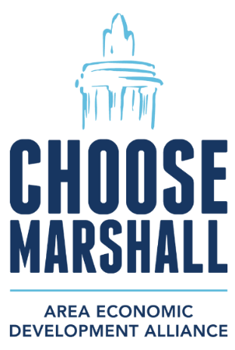

FOR IMMEDIATE RELEASE: Friday, April 19, 2024
CONTACT: Amy Bailey, Byrum & Fisk Advocacy Communications, abailey@byrumfisk.com
MAEDA applauds Ford’s $25,000 donation to the city of Marshall for tree planting across the city
Ford’s contribution will help city plant trees, take steps to regain Tree City USA status
MARSHALL, Mich. — The Marshall Area Economic Development Alliance (MAEDA) is applauding Ford Motor Co.’s $25,000 donation to the city of Marshall to support its efforts to plant new trees throughout the city to earn Tree City USA recognition once again.
Ford’s donation will help the city reach its long-held goal of replacing and adding new street and park trees, which help provide shade, natural beauty, clean air, and higher property values, in our neighborhoods and downtown. This investment coincides with Earth Day on Monday, April 22, and the city’s Arbor Day on Friday, April 26.
“This investment from Ford will provide new trees for Marshall, benefiting the city and those visiting our charming community for generations to come,” said Marshall mayor Jim Schwartz. “We are excited to make this long-term investment in the city and take the next steps toward earning Tree City USA recognition.”
The Tree City USA program provides communities with a framework to maintain and grow their tree cover. It also gives them an avenue to celebrate their work, showing residents and visitors they are invested in protecting our land, air, and water.
“At Ford, we are committed to being a great neighbor and employer and this donation is just one example of our mission to give back to the Marshall community,” said Gabby Bruno, Ford’s community relations director. “Planting trees in Marshall is a long-lasting investment in the community that will benefit area residents long into the future.”
Construction is progressing at Ford’s BlueOval Battery Park Michigan in Marshall with hundreds of workers on the site. Roughly 245 acres at the southern edge of the site, along the Kalamazoo River, will be preserved for generations to come and protected against future industrial development.
###

